
The Scrum Game
By William Wake and Mike Cohn
Version 1.0
April 28, 2007

Winning The Game
This is a collaborative game; all players win or lose together. The game is designed for play by two to six players but can realistically be played by any number.
The goal is to burn down a certain amount of work and conduct a sprint review before the tenth day of the sprint ends. The game starts with the team attempting to burndown 300 hours of work. However, this amount can be increased or decreased based on where players land during sprint planning. Hours are burned down (or up) whenever a player lands on burndown or burnup spaces on the board.

Board
The board looks like the Scrum two-circle diagram as shown below.
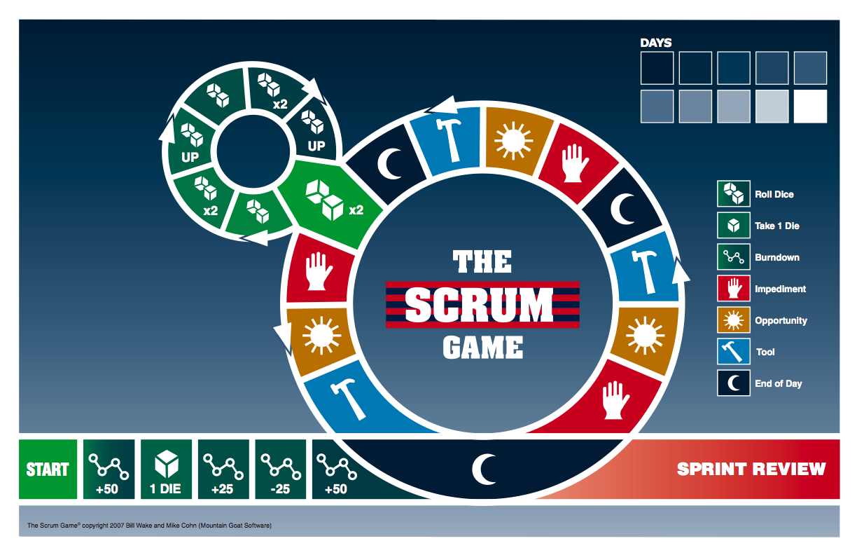
Spaces on the board have the following meanings as indicated within each space:
Icon | Space Type | Meaning
 | End of a day | The game ends when ten days have been completed.
 | Tool | Draw one card from the deck of tool cards. If all tool cards have been used, shuffle the discarded tools and reuse them.
 | Impediment | Draw one card from the deck of impediment cards. If all impediments have been used, shuffle the discarded impediments and reuse them.
 | Opportunity | Draw an opportunity card from the deck and discuss the situation described on it.
 | Report progress | Roll the progress dice and burndown the number of hours earned on the dice. Spaces marked with x2 allow you to burn down twice the number of hours earned on the dice. Spaced annotated with “UP” cause you to burn up the number of hours shown on the dice.
 | Take an additional die | Add one more die to your set of progress dice. This will allow you to burn down work more quickly.
 | Adjust the burndown chart | These spaces appear during sprint planning only and result in the team commit to the number of additional or fewer hours shown on the space.

Starting the Game
Before the game begins do the following:
- Shuffle the tool cards and place them on or near the board.
- Shuffle the impediment cards and place them on or near the board.
- Shuffle the opportunity cards and place them on or near the board.
- Have each player select a token and place it in the Start Here space on the board.
- Set aside two specially-marked dice (labeled 1 through 5 plus a “scrum” symbol on the sixth side) to be used for moving around the board.
- Set aside three specially-marked dice for use as progress dice. These dice will be rolled to determine the number of hours burned down (or up) as explained later.

Sprint Planning
The first five spaces on the board represent sprint planning. For each player’s first move, the player rolls one die. If the die displays a number from 1-5, move your piece that many spaces and perform the action described. If you roll a scrum, you do not move. On your next and all subsequent turns, roll two dice.
Note: It is possible that you will land on more than one sprint planning space. If, for example, you roll a one on your first turn and double ones on your second turn you will land on the first and third sprint planning spaces. Similarly, you may land on no sprint planning spaces. If your first roll is a scrum and your second roll is double fives you will move past sprint planning and onto the main part of the board.

Turns
After the first turn, each player may either roll two dice or play a tool that will remove an impediment from himself or another player. To play a tool the player explains why the tool will remove the impediment. If all other players agree, the impeded player is no longer impeded and the tool is discarded.

Days
Each time a player lands on an End of Day space the Days indicator in the top right of the board is moved one day forward. The game is meant to simulate a ten-day sprint and ends immediately once a player lands on an End of Day space that moves the indicator to the tenth day.

What to Do When Impeded
If you land on an Impeded space, draw the top card from the Impediment deck. That card describes your impediment. While impeded you cannot move around the board. To indicate you are impeded, place the Impediment card in front of you and put a pig piece on the playing board next to your pawn. You may become unimpeded in either of two ways:
- Another player may play a tool card instead of moving. It is obvious how some tool cards can remove certain impediments. For example, “pair with someone on the team” is a logical way to remove the “what you’re working on is new and challenging” impediment. The relationship between other tools and impediments will be much less obvious. It is entirely up to the team to determine if the proposed tool can indeed remove the impediment.
- On your turn, roll the two dice (as you normally would) and have at least one scrum show up. If you roll one scrum and one number, you may move that number of spaces. If you roll two scrums, the impediment is removed but you do not get to move on that turn. If you roll no scrums, you remain impeded.

Burndown or Burnup
Whenever a player lands on a Roll Dice space on the board, the player rolls the number of progress dice currently earned by the team (from 3-10 dice). The amount to be burned up or down is indicated by the values shown on the dice with each scrum doubling the largest available number thrown. For example, consider the values shown in the following table:
Rolled | Burn up or down
1, 1, 3, scrum | 8 (3 + 3 + 1 + 1)
5, scrum, scrum | 10 (5 + 5)
scrum, scrum | 0
1, 2, 3, scrum, scrum | 11 (3 + 3 + 2 + 2 + 1)
1, 3, 5 | 9 (5 + 3 + 1)
In the first case, the scrum is used to double the three and added to the two ones for a total of eight.
Note: The same number of progress dice are used by all team members. That is, you do not keep track that one person rolls four and another rolls five. All members of the team roll the same dice when they land on a burnup or burndown space.

Opportunity Cards
If you land an Opportunity space, draw the top card from the Opportunity deck. If all Opportunity cards have been drawn, treat the space as empty and do nothing special. Opportunity cards
- Discuss. If you draw a discussion card the entire team discusses the opportunity facing the team for five minutes. At the end of that time, if the whole team agrees that they have adequately addressed the situation, the team is awarded one additional progress dice. Note that the team may never be rolling more than ten progress dice.
- Some opportunity cards direct the player to “Go to the Daily Scrum.” If you draw this card, move your piece to the daily scrum (the large space connecting the two circles). On your next turn, move into the daily scrum circle.
- Some opportunity cards direct the player to “Go to the End of Day” space. If you draw this card, move your piece to the End of Day space that is between the sprint planning meeting and the sprint review meeting. Be sure to advance the Day indicator in the center of the game board.

Tracking Progress
Track the number of hours of sprint burndown remaining on the provided sprint burndown sheets. Keeping a daily running count of how many hours of progress you’ve earned and then add a new dot to the burndown chart whenever a player lands on an end of day space.

Ending the Game
If all work is burned down before the tenth day, the team needs to conduct a sprint review. To do this, all players must continue to roll and move until they reach the sprint review space. Players who are impeded have their impediments immediately resolved once the burndown reaches zero. Once all work is burned down, the only spaces on the board that matter are end of day spaces. To win the game, all players must reach the final sprint review space before a player lands on a tenth end of day space.
Tip: You can move to the Sprint Review space before all work is burned down, but you cannot leave the sprint review area once you’ve entered it. If almost all work has been completed, you may want to do this rather than go around the whole board if you think another player will finish the last few points of burndown.
Note: It is not necessary to burndown below zero. Since the only spaces that matter are end-of-day all players should try to proceed directly to the sprint review as quickly as possible.

Ssssh, don’t tell Ken.

